Ideation Phase
Brainstorm & Idea Prioritization Template

Date | 18 FEB 2026
Team ID | LTVIP2026TMIDS80351
Project Name | AutoSage App Using Gemini Flash
Maximum Marks

Brainstorm & Idea Prioritization Template:
Step-1: Team Gathering, Collaboration and Select the Problem Statement
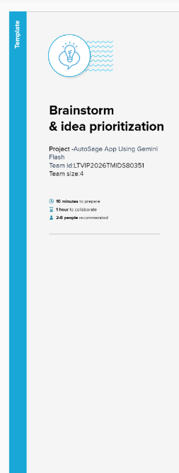
Step-2: Brainstorm, Idea Listing and Grouping

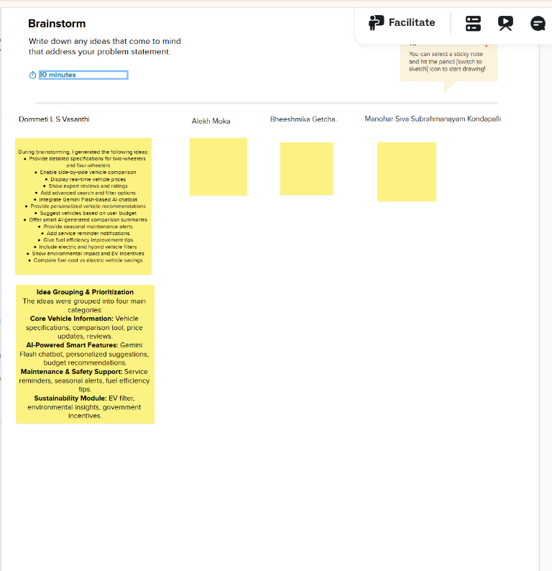
Step-3: Idea Prioritization
